

Unveiling The Virtual Classroom: An In-Depth Analysis Of The Online Education System

**Name: Bharti Khemani**

**Institute: A. P. Shah Institute of Technology, Thane, Maharashtra**

**Platform used: IBM Cognos Analytics on Cloud**

1. **INTRODUCTION**
   1. Overview

Online classes and technology have emerged as a superhero during the lockdown days. We have all been under house arrest but are still connected with the world of education. Due to the lockdown, students have not been able to stay connected with the outer world and the lack of exposure is evident. The only reprieve for the students’ mental well-being has been the transition to online classes. Teachers made sure that the learning for students was not compromised, so they took a great leap forward to find solutions and create new learning environments for their students to ensure that learning never stops. With the rapid advancements in technology and the widespread availability of internet access, online education has gained significant popularity in recent years.

* 1. Purpose

This project aims to delve deep into the various aspects of online education, examining its strengths, weaknesses, opportunities, and challenges. The outcomes of this project will provide valuable insights for educational institutions, policymakers, and online learning platforms to enhance the effectiveness and accessibility of online education. This analysis of the online education system aims to contribute to the ongoing dialogue on the future of education and help shape a more inclusive, engaging, and effective learning environment in the digital age.

1. **LITERATURE SURVEY**
   1. Existing problem

**Digital Divide:** Not all students have equal access to reliable internet connections, devices, or suitable environments for online learning. This digital divide can lead to unequal access to education and learning opportunities.

**Technology Issues:** Technical problems such as connectivity issues, software glitches, and device compatibility can disrupt the learning experience for both students and teachers.

**Engagement and Motivation**: Keeping students engaged and motivated in a virtual setting can be challenging. The absence of face-to-face interaction and physical classroom dynamics can lead to decreased motivation and participation.

**Lack of Personal Interaction:** Virtual classrooms can lack the personal connection and rapport that often develops between students and teachers in traditional classrooms. Building relationships and addressing individual student needs can be more difficult in an online environment.

**Assessment and Cheating:** Ensuring the integrity of assessments and preventing cheating can be more complex in virtual classrooms. Monitoring students during online exams and verifying the authenticity of submitted work can be challenging.

**Isolation and Well-being:** Extended periods of virtual learning can contribute to feelings of isolation and loneliness among students. Additionally, prolonged screen time can have negative effects on students' physical and mental well-being.

**Teacher Training and Preparedness:** Many educators may not be fully equipped with the skills and training required for effective online teaching. Adapting teaching methods to the virtual environment can be a significant hurdle.

**Equitable Access to Resources:** Providing equal access to educational resources, including digital textbooks, online libraries, and educational software, can be difficult, particularly for economically disadvantaged students.

**Time Management and Self-Discipline:** Online learning requires strong time management and self-discipline skills. Some students may struggle with organizing their time and staying focused without direct supervision.

**Pedagogical Shift:** Transitioning from traditional teaching methods to effective online instruction involves a pedagogical shift. Some educators may struggle to adapt their teaching strategies for virtual classrooms.

**Parental Involvement:** Younger students often require parental assistance and supervision during virtual learning. This can be challenging for working parents and may affect the quality of the learning experience.

**Privacy and Data Security:** Virtual classrooms involve sharing personal information and data online. Ensuring the privacy and security of students' information is crucial but can be difficult to manage.

**Cultural and Language Barriers:** Virtual classrooms may have students from diverse cultural and linguistic backgrounds. Overcoming language barriers and promoting inclusivity can be complex.

**Hands-On and Lab-Based Learning:** Subjects that require hands-on activities, experiments, and practical skills can be challenging to teach effectively in a virtual setting.

**Teacher-Student Interaction:** In a virtual classroom, individual attention and real-time interaction between teachers and students might be limited, potentially impacting students who require additional support.

These challenges emphasize the importance of a holistic approach to virtual education, addressing not only the technical aspects but also the social, emotional, and pedagogical dimensions of learning. Solutions may involve a combination of technology, policy changes, teacher training, and ongoing research to continually improve the virtual classroom experience.

2.2 Proposed solution

**Closing the Digital Divide:** Governments and educational institutions can work together to provide devices and reliable internet access to students who lack them. Implement initiatives to offer subsidized or free internet access and devices to low-income students.

**Technology Support and Training:** Offer comprehensive training and workshops for teachers to enhance their digital literacy and online teaching skills. Provide technical support to address connectivity issues and software glitches promptly.

**Engagement Strategies:** Incorporate interactive and engaging learning materials, such as videos, simulations, and gamified content, to keep students motivated. Use discussion boards, breakout rooms, and virtual group activities to encourage student participation and collaboration.

**Personalized Learning:** Implement adaptive learning platforms that tailor content to individual student needs, pacing, and learning styles. Provide students with options for choosing assignments or projects that align with their interests and strengths.

**Promote Social Interaction:** Create online communities where students can interact, discuss topics, and collaborate on projects outside of class hours. Organize virtual clubs, study groups, and extracurricular activities to foster a sense of belonging.

**Well-being and Support:** Offer resources for mental health support and encourage students to take breaks and practice self-care. Provide guidelines for managing screen time and balancing online learning with offline activities.

**Assessment Integrity:** Design assessments that emphasize critical thinking, problem-solving, and application of concepts rather than rote memorization. Implement online proctoring tools and methods to monitor students during exams and prevent cheating.

**Pedagogical Adaptation:** Provide resources and training to help educators adapt their teaching methods for the virtual environment. Encourage experimentation with various online teaching strategies to find what works best for each teacher.

**Equitable Access to Resources:** Collaborate with publishers and organizations to provide digital textbooks and resources at affordable rates or for free. Develop open educational resources (OER) that can be accessed by all students without financial barriers.

**Parental Involvement:** Offer guidance and resources to help parents support their children's virtual learning effectively. Foster communication between teachers and parents to create a supportive learning environment.

**Data Privacy and Security:** Implement robust data security measures to protect students' personal information and ensure compliance with privacy regulations. Educate students about online safety and responsible digital behavior.

**Hybrid Learning Models:** Consider a hybrid approach that combines virtual and in-person learning to provide students with a mix of experiences. Hybrid models can address the limitations of each approach while maximizing benefits.

**Continuous Improvement and Research:** Regularly gather feedback from students, parents, and teachers to identify areas of improvement in the virtual classroom experience. Invest in research and development to explore innovative technologies and methods that enhance virtual learning.

**Inclusive Design:** Design virtual classrooms with accessibility in mind, ensuring that content is usable by individuals with disabilities. Provide closed captioning, screen reader compatibility, and other accessibility features.

**Collaboration and Partnerships:** Collaborate with technology companies, education experts, and policymakers to create a holistic approach to virtual education. Share best practices and success stories to drive positive change across educational institutions.

Ultimately, addressing the challenges of the virtual classroom requires a collaborative effort involving educators, students, parents, policymakers, and technology providers. By implementing these proposed solutions and staying adaptable to evolving needs, the virtual classroom experience can be improved and optimized for effective learning.

1. **THEORETICAL ANALYSIS** 3.1 Block diagram

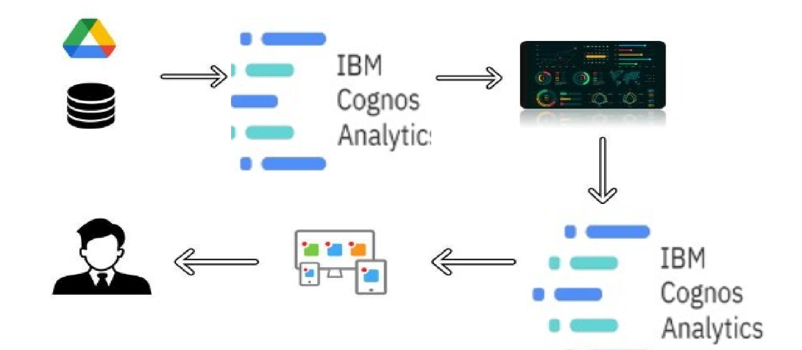

3.2 Hardware / Software designing Hardware:

Operating system: Linux- Ubuntu 16.04 to 17.10, or Windows 7 to 10, with 2GB RAM (4GB

preferable) Software:

|  |  |
| --- | --- |
| * Python, * Python For Data Analysis, | ● IBM Cognos Analytics ● Exploratory Data Analysis, |

● Python For Data Visualization,

1. **EXPERIMENTAL INVESTIGATIONS**

**Research Question Formulation:** Define clear research questions or hypotheses that you want to investigate through experiments. These questions could relate to student engagement, learning outcomes, user satisfaction, etc.

**Experimental Design:**

**Controlled Variables:** Identify the variables that you will control during the experiment to maintain consistency.

**Independent Variable:** Determine the variable you are manipulating, such as different teaching methods or interface designs.

**Dependent Variables:** Identify the variables you will measure as outcomes, like student performance, engagement metrics, etc.

**Participant Selection:**

**Sample Size:** Determine the number of participants needed for statistical significance.

**Randomization:** Randomly assign participants to different experimental conditions to reduce bias.

**Data Collection:**

**Quantitative Data:** Gather quantitative data, such as test scores, completion rates, time spent on tasks, etc.

**Qualitative Data:** Collect qualitative data through surveys, interviews, or focus groups to understand user experiences and perceptions.

**Experiment Execution:** Administer the experiment to participants, ensuring consistent procedures across all conditions. Use the virtual classroom platform to deliver educational content and interactive activities.

**Data Analysis:** Analyze the collected data using appropriate statistical methods. Compare outcomes across different experimental conditions to assess their impact.

**Interpretation of Results:** Interpret the statistical findings to answer the research questions or test the hypotheses. Consider both quantitative and qualitative data to provide a comprehensive understanding.

**Discussion and Conclusion:** Discuss the implications of the results for the effectiveness of the virtual classroom platform. Address any limitations and suggest areas for further research or improvements.

**Reporting:** Compile your findings in a research report, academic paper, or presentation. Clearly present the methodology, results, and conclusions of the experimental investigations.

**Iterative Process:** If necessary, refine your research questions or experimental design based on the results obtained.

**Ethical Considerations:** Ensure that the experimental investigations adhere to ethical guidelines, especially when involving human participants.

**Peer Review:** Consider submitting your findings to peer-reviewed journals or conferences in the field of education or technology.

1. **FLOWCHART**

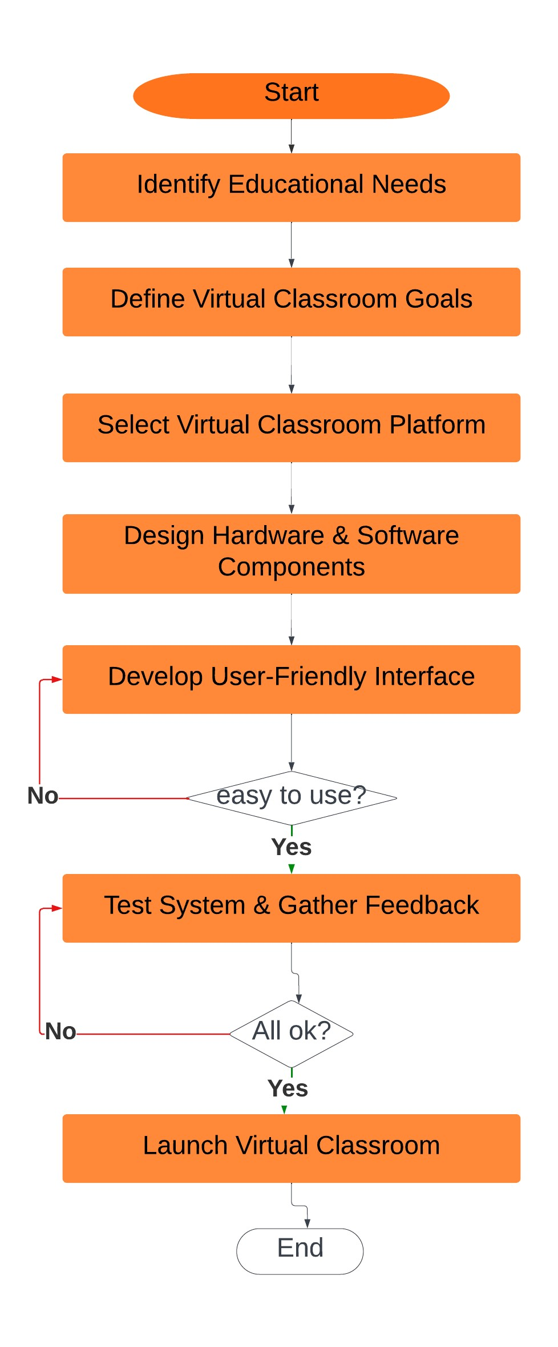

1. **RESULT**

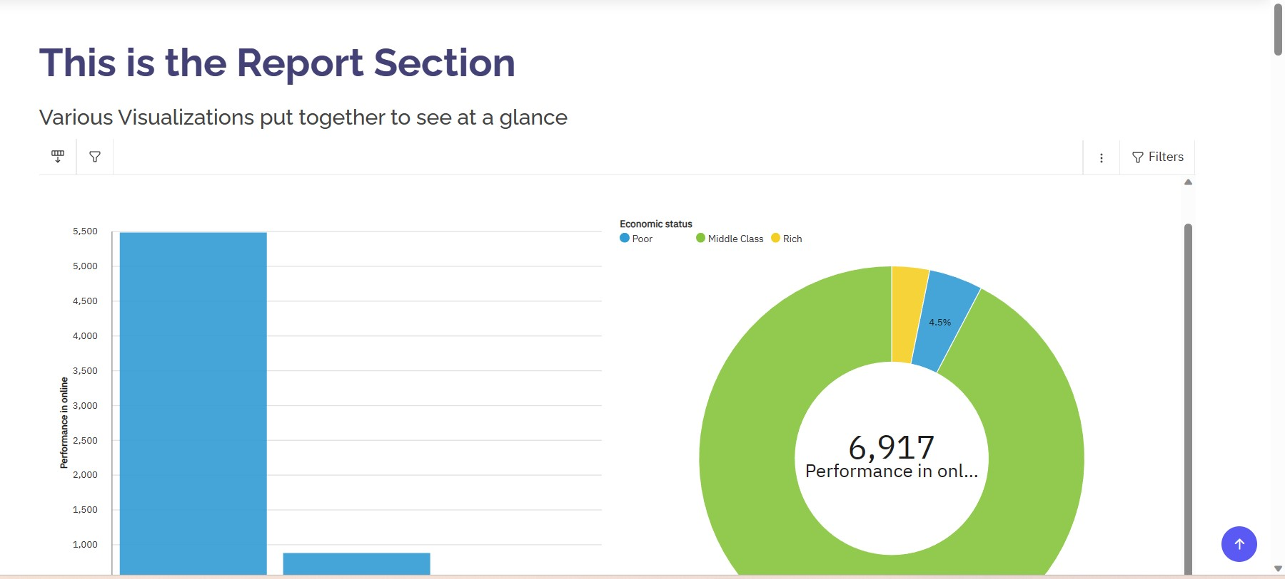

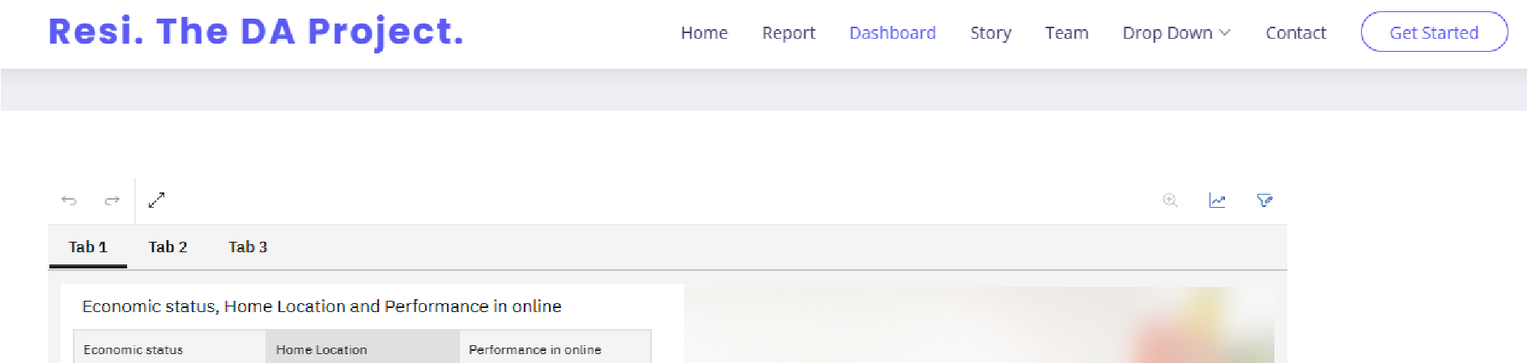Fig: Report Section

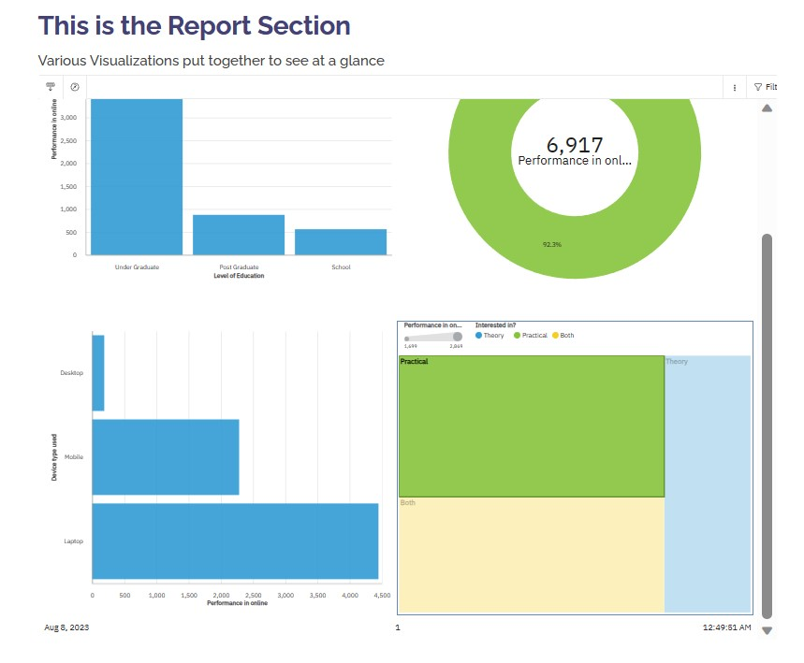

Fig: Dashboard Section

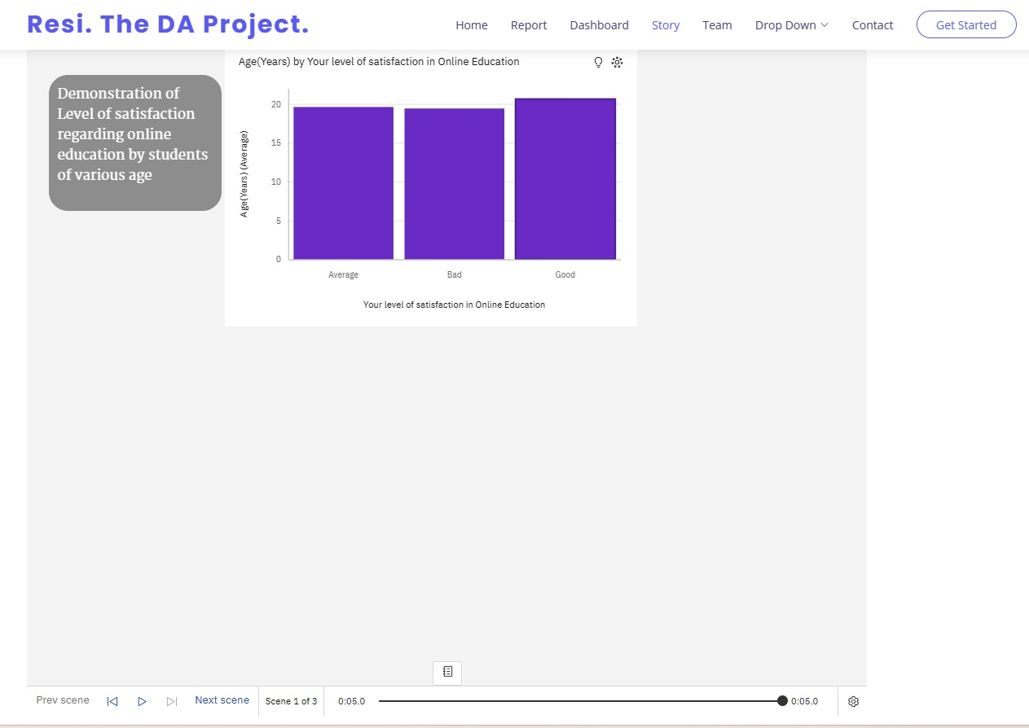

Fig: Story Section

1. **ADVANTAGES & DISADVANTAGES**

**Advantages:**

1. **Accessibility:** Virtual classrooms allow learners from different geographical locations to access education without the need for physical presence, making education more accessible to diverse populations.
2. **Flexibility:** Students can learn at their own pace and schedule, accommodating different learning styles and personal commitments.
3. **Cost-Effective:** Virtual classrooms can reduce costs associated with traditional classroom settings, such as transportation, accommodation, and physical resources.
4. **Global Reach:** Educators can reach a wider audience, crossing borders and time zones to offer education to a global community.
5. **Diverse Learning Resources:** Virtual classrooms can incorporate a variety of multimedia resources like videos, interactive simulations, and digital textbooks to enhance learning.
6. **Personalization:** Adaptive learning technologies can tailor educational content to individual learning needs, promoting more effective learning outcomes.
7. **Recorded Sessions:** Sessions can be recorded and made available for later review, helping students revise concepts and catch up on missed classes.
8. **Collaboration:** Virtual classrooms can foster collaborative learning through online group projects, discussions, and shared documents.
9. **Reduced Environmental Impact:** With fewer students commuting and less physical infrastructure required, virtual classrooms can contribute to a smaller carbon footprint.
10. **Inclusive Learning:** Virtual classrooms can accommodate students with disabilities by providing accessibility features like closed captioning and screen reader compatibility.

**Disadvantages:**

1. **Digital Divide:** Not all students have equal access to necessary technology and reliable internet connections, leading to educational inequality.
2. **Isolation:** Lack of face-to-face interaction can lead to feelings of isolation and reduced social interaction, affecting the overall learning experience.
3. **Technical Challenges:** Technical issues such as connectivity problems, software glitches, and compatibility issues can disrupt learning.
4. **Self-Discipline:** Online learning requires strong time management and self-discipline, which can be challenging for some students.
5. **Lack of Hands-On Experience:** Subjects requiring hands-on activities, practical labs, and physical presence may suffer in a virtual environment.
6. **Cheating Concerns:** Ensuring the integrity of assessments and preventing cheating can be more complex in virtual classrooms.
7. **Teacher-Student Interaction:** Building a personal rapport between teachers and students might be more challenging in a virtual setting.
8. **Dependence on Technology:** Technical failures can halt the learning process and create frustration for both educators and learners.
9. **Screen Fatigue:** Extended screen time can lead to digital eye strain and other health issues.
10. **Limited Monitoring:** Teachers may find it harder to monitor student engagement and attention in a virtual setting.

**8 APPLICATIONS**

PlaThe solution of "Unveiling The Virtual Classroom" – combining hardware and software design to create a comprehensive online education platform – can be applied in various areas and scenarios. Here are some potential applications:

1. **K-12 Education**: The virtual classroom can be used in primary and secondary education to facilitate remote learning, homework assignments, quizzes, and interactive lessons.
2. **Higher Education**: Universities and colleges can offer online courses, virtual lectures, collaborative projects, and distance learning programs through the virtual classroom platform.
3. **Professional Developmen**t: Businesses and organizations can use the platform for employee training, workshops, seminars, and skill development programs.
4. **Continuing Education**: Adults seeking to learn new skills or pursue additional qualifications can access online courses and resources through the virtual classroom.
5. **Remote Workshops and Conferences**: The platform can be used to conduct virtual workshops, conferences, and seminars, enabling global participation without the need for physical presence.
6. **Tutoring and Mentoring**: Tutors and mentors can offer personalized coaching and guidance to students across different subjects and disciplines.
7. **Language Learning**: Virtual classrooms can facilitate language learning by enabling students to interact with native speakers, participate in group discussions, and practice speaking.
8. **Special Education**: The platform can provide tools for educators to deliver specialized education and support to students with diverse learning needs.
9. **Skill-Based Training**: The virtual classroom can host training programs for practical skills, such as cooking, DIY projects, music lessons, and more.
10. **Corporate Training**: Companies can use the platform to onboard new employees, provide ongoing training, and ensure consistent skill development.
11. **Professional Certifications**: The platform can offer courses and resources to prepare individuals for professional certifications and licensure exams.
12. **Community Learning**: Local communities or interest groups can use the virtual classroom to organize learning sessions, workshops, and knowledge-sharing events.
13. **Global Collaboration**: The platform can foster collaboration among students, educators, and professionals from around the world, promoting cultural exchange and diverse perspectives.
14. **Test Preparation**: Virtual classrooms can host test preparation courses for standardized exams like SAT, GRE, and more.
15. **Lifelong Learning**: The solution caters to individuals of all ages who want to continue learning and acquiring new knowledge throughout their lives.
16. **CONCLUSION**

Virtual Faculty Build-A-Thon is a project development activity where participants are enrolled in a project listed under distinct technology categories after acquiring crucial knowledge on the IBM cloud services and open source technologies in the Bootcamp. Thus, under this activity a project on IBM cognos was built where various data visualization and exploration was learnt.

The dashboard, story and reports created in IBM cognos were integrated with the UI using flask in VS Code and run on the system localhost.

1. **FUTURE SCOPE**

The future scope of "Unveiling The Virtual Classroom" involves advanced integration of technologies such as VR, AR, and AI to provide immersive and personalized learning experiences. Hybrid learning models that combine in-person and virtual education could become more prevalent. Data analytics will offer insights into student performance, and social learning platforms will encourage collaboration. Lifelong learning networks, global collaborations, and sustainable education solutions are anticipated. Language translation tools and enhanced assessment methods will further enrich virtual classrooms. Integration with emerging technologies and the potential for transformative changes in education underscore the promising future of virtual classrooms.

**APPENDIX**

A. Source Code (Important Snippets)

<header id="header" class="fixed-top ">

<div class="container d-flex align-items-center justify-content-between">

<h1 class="logo"><a href="index.html">Resi. The DA Project.</a></h1>

<!-- ======= About Section ======= -->

<section id="about" class="about">

<div class="container">

<div class="row content">

<div class="col-lg-6">

<h2>This is the Report Section</h2>

<h3>Various Visualizations put together to see at a glance</h3>

</div>

<iframe

src="https://us3.ca.analytics.ibm.com/bi/?pathRef=.my_folders%2Fdeepali-pro ject%2Breport&amp;closeWindowOnLastView=true&amp;ui_appbar=false&amp;ui_nav bar=false&amp;shareMode=embedded&amp;action=run&amp;format=HTML&amp;prompt= false" width="1100" height="1000" frameborder="0" gesture="media" allow="encrypted-media" allowfullscreen=""></iframe>

</div>

</div>

</section><!-- End About Section -->

<!-- ======= Services Section ======= -->

<section id="services" class="services">

<div class="container">

<iframe src="https://us3.ca.analytics.ibm.com/bi/?perspective=dashboard&amp;pathRef =.my_folders%2Fdeepali%2Bproject%2Bdashboard&amp;closeWindowOnLastView=true &amp;ui_appbar=false&amp;ui_navbar=false&amp;shareMode=embedded&amp;action= view&amp;mode=dashboard&amp;subView=model00000189b6b909df_00000002" width="1100" height="1000" frameborder="0" gesture="media" allow="encrypted-media" allowfullscreen=""></iframe>

</div>

</section><!-- End Services Section -->

<!-- ======= Portfolio Section ======= -->

<section id="portfolio" class="portfolio">

<div class="container">

<iframe src="https://us3.ca.analytics.ibm.com/bi/?perspective=story&amp;pathRef=.my _folders%2Fdeepali%2Bproject%2Bstory&amp;closeWindowOnLastView=true&amp;ui_ appbar=false&amp;ui_navbar=false&amp;shareMode=embedded&amp;action=view&amp ;sceneId=model00000189d12213a5_00000002&amp;sceneTime=0" width="1100" height="1000" frameborder="0" gesture="media" allow="encrypted-media" allowfullscreen=""></iframe>

</div>

</section><!-- End Portfolio Section -->

**.**